Title of Your Research Paper (Use a “Arial, Helvetica, or Calibri”, Size 18 pt, Bold, Center-aligned)
Firstname Lastname¹, Firstname Lastname² (Times New Roman, 12 pt, Bold, Centered)
¹ Department, Organization/University, Country (Times New Roman, 10 pt, Normal, Centered)
² Department, Organization/University, Country
Corresponding author: corresponding.author@iceis2026.dz

Abstract (Titles: Sans Serif, Bold, and Blue)
Place the abstract and keywords between two horizontal lines. For the text, use Times New Roman, 10 pt, Justified. The abstract should summarize the objectives, the methodological approach, and the main findings. It should not exceed 250 words. For the general page setup, the document must use A4 paper size (21 x 29.7 cm) with margins set to 3 cm at the top and 2.5 cm for the bottom, left, and right. Page numbering must be completely disabled so that no page numbers are included. Additionally, set the header to "Different First Page" ensuring the header on the first page remains empty. From the second page onwards, insert the designated header text, formatted as centered, small 10 pt, italic, and dark green.
Keywords: Provide 3 to 5 keywords separated by commas (Text: Times New Roman, 10 pt, Justified)

- Introduction (Main Sections: Size 14 pt, Bold, Blue, Sans Serif)
Provide the background of your research, the motivation behind the study, and the specific energy innovation challenges addressed in the context of ICEIS 2026. For all body text in the document, use Times New Roman, 11 pt, Justified, single-spaced.

Physical and Mathematical Models
Describe the experimental setup, numerical models, or theoretical frameworks used. Note that your paper should ideally be organized into the following four sections: 1. Introduction, 2. Physical and Mathematical Models, 3. Results and Discussion, 4. Conclusion.

2.1 Physical Model (Sub-sections: Size 11 pt, Bold, Blue, Sans Serif)
One consider fluid flow... (Ensure body text remains Times New Roman, 11 pt, Justified, single-spaced).

Mathematical Model

For fluid dynamics studies, the governing equations should be presented here. Use the Equation Editor for all mathematical expressions. Equations must be centered and numbered consecutively on the right-hand side:
 | $$\frac{∂ρ}{∂t}+∇.\left(ρu\right)=0$$ | (1)
Results and Discussion
Present your data, simulations, and analysis. Ensure that all figures and tables are clearly labeled and discussed in the text. As shown in Figure 1 and Table 1, the...

3.1 Tables and Figures
- Tables: Table headings must be placed above the tables.
- Figures: Figure captions must be centered below the figures. Minimum figure resolution: 150dpi. Alignment: Figures must be centered.
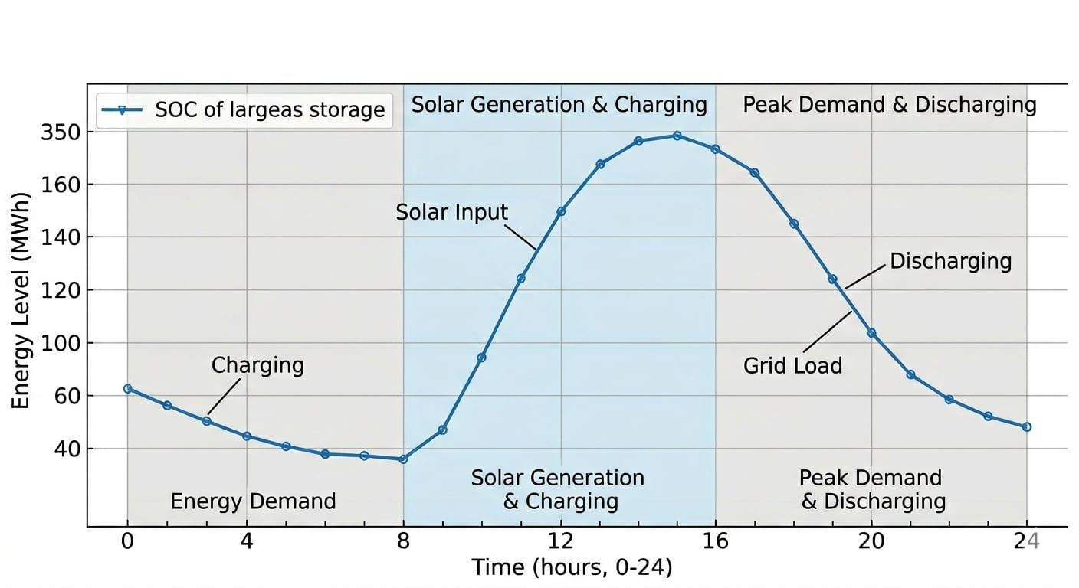

Figure 1. Optimal battery operation in a microgrid. (Captions: Place below the figure. Size: Small 10 pt. The label "Figure 1." must be in Bold, Sans Serif. Description in normal text).
- Conclusion
Summarize the key contributions of the work and its implications for energy sustainability and innovation.
References (Title: Size 14 pt, Bold, Blue, Sans Serif)
(Use the IEEE numbering style [1]. List references at the end of the paper in Times New Roman, 10 pt).
[1] A. Author, B. Author, and C. Author, "Title of the journal article," Journal of Renewable Energy, vol. 15, no. 2, pp. 120-135, 2026.
[2] D. Specialist, Hydrogen Storage and Fluid Dynamics, 2nd ed. Algiers, Algeria: Energy Press, 2025.
[3] E. Researcher, "Innovative turbine design for wind farms," in Proc. International Conference on Energy Innovation and Sustainability (ICEIS), Algiers, 2026, pp. 45-50.
[4] International Energy Agency, "Hydrogen for Net Zero," 2025. [Online]. Available: https://www.iea.org/reports/hydrogen

